Willian Bernatzki Woellner

30021175

Optimisation Report

AT2

Table of Contents

Google Lighthouse 2

First Section - Result and Recommendation 2

Figure 1 Home Page (index.php) 3

Figure 2 - Search Page (search.php) 4

Figure 3 - Top 10 (top_ten.php) 4

Figure 4 - Admin Login (adminLogin.php) 5

Figure 5 - Unsubscribe Membership (unsubscribeMembership.php) 5

Figure 6 - All Membership (allMembership.php) 6

Last Section - Result and Recommendation 7

Figure 1 – Top 10 (top_ten.php) 7

References 8

# Google Lighthouse

Lighthouse is an open-source, automated tool for improving the quality of web pages. You can run it against any web page, public, or requiring authentication. It has audits for performance, accessibility, progressive web apps, SEO, and more. (Lighthouse, 2020)

The Google Lighthouse has been used to create the Optimisation Report because it is free, easy to run, and works on local servers. The main pages have been analyzed to create a complete report.

The Optimisation Report consists of two sections: First Section is Analyzed the system pages without changes to increase the performance and the Last section presents all results after the changes.

## First Section - Result and Recommendation

|  |  |  |  |  |
| --- | --- | --- | --- | --- |
| **Page** | **File** | **Performance** | **Description result** | **Comment** |
| Home Page | index.php | 100% | No significant changes are necessary. | Ref. Figure 1 |
| Search Page | search.php | 100% | No significant changes are necessary. | Ref. Figure 2 |
| Top 10 | top_ten.php | 100% | No significant changes are necessary, but the Diagnostics section indicated to Set an explicit width and height on image elements to reduce layout shifts and improve CLS. | Ref. Figure 3 |
| Admin Login | adminLogin.php | 100% | No significant changes are necessary. | Ref. Figure 4 |
| Unsubscribe Membership | unsubscribeMembership.php | 100% | No significant changes are necessary. | Ref. Figure 5 |
| All Membership | allMembership.php | 100% | No significant changes are necessary. | Ref. Figure 6 |

## Figure 1 Home Page (index.php)

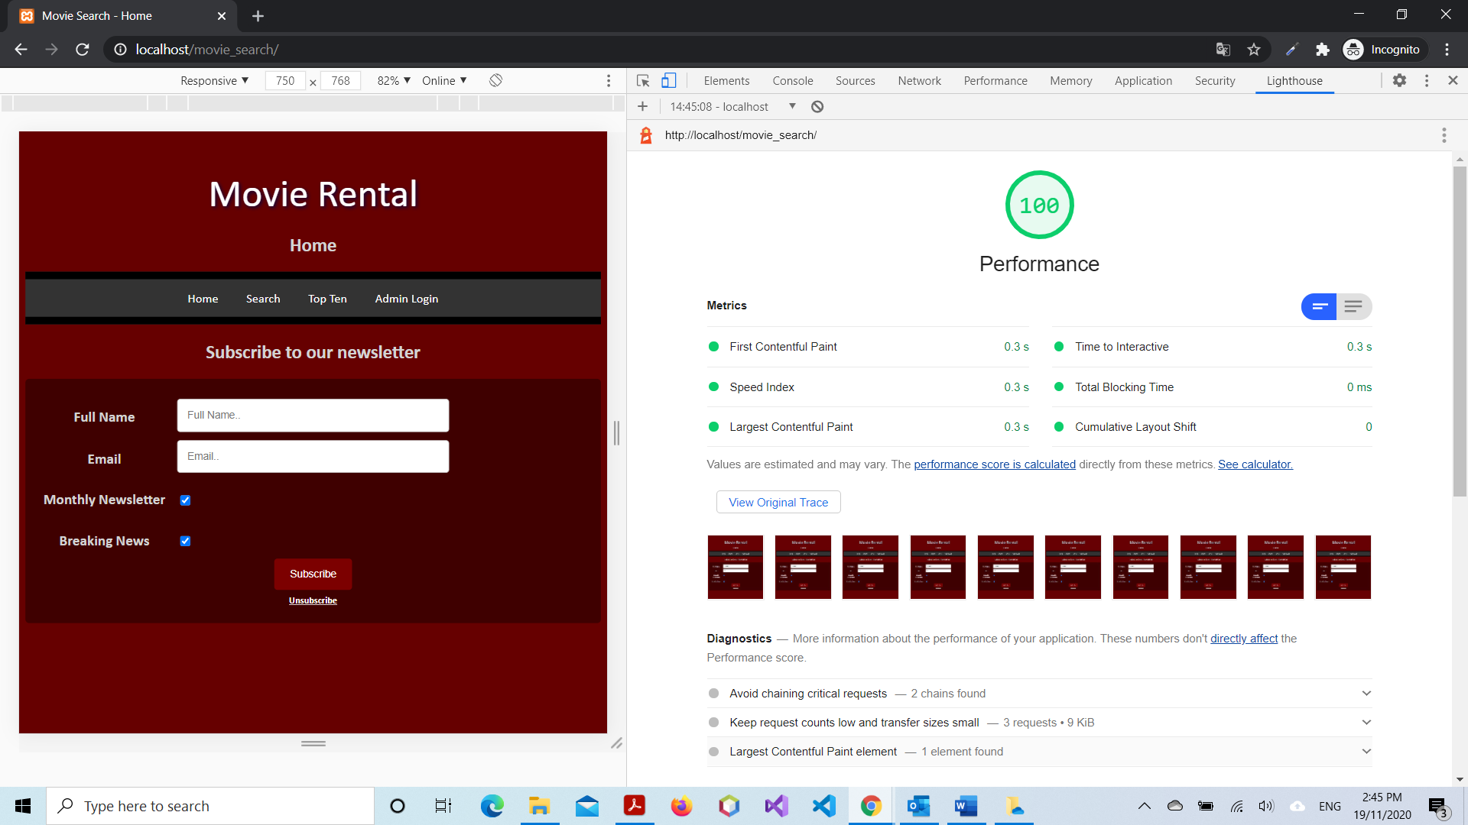

## Figure 2 - Search Page (search.php)

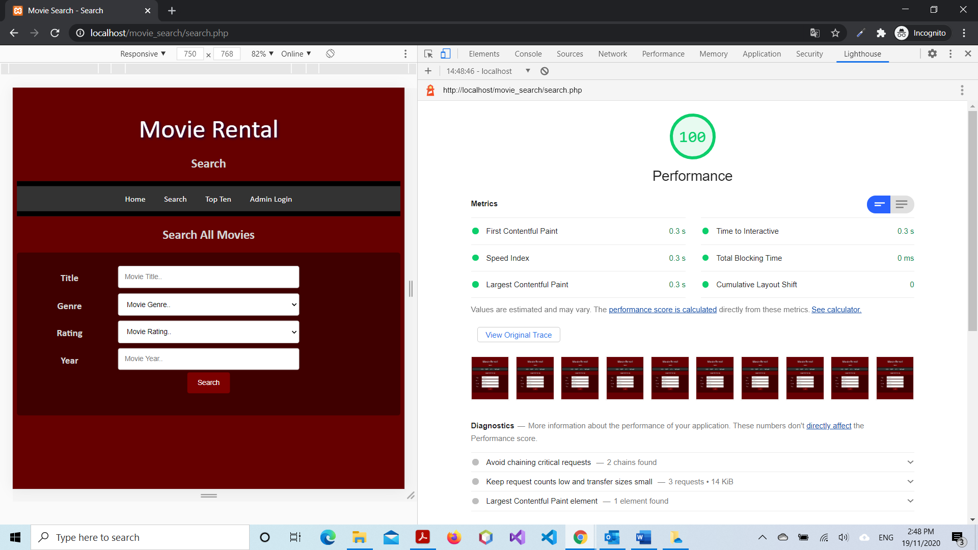

## Figure 3 - Top 10 (top_ten.php)

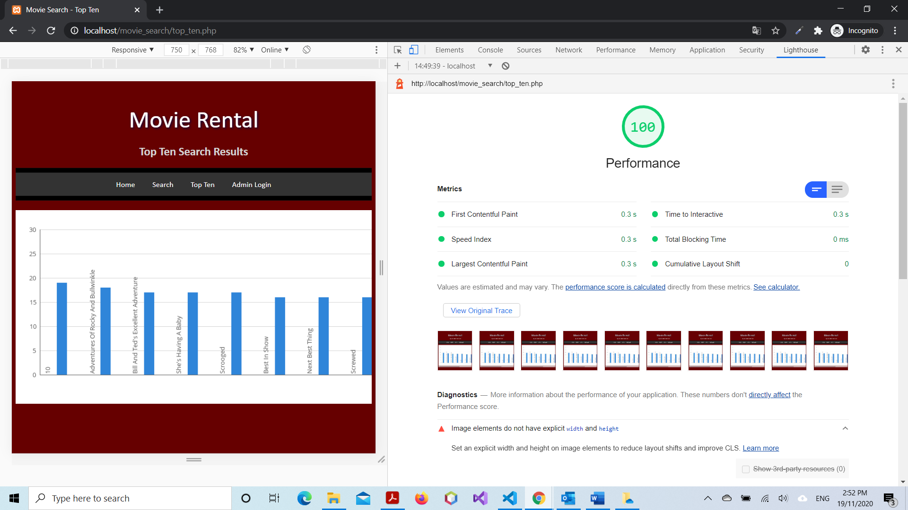

## Figure 4 - Admin Login (adminLogin.php)

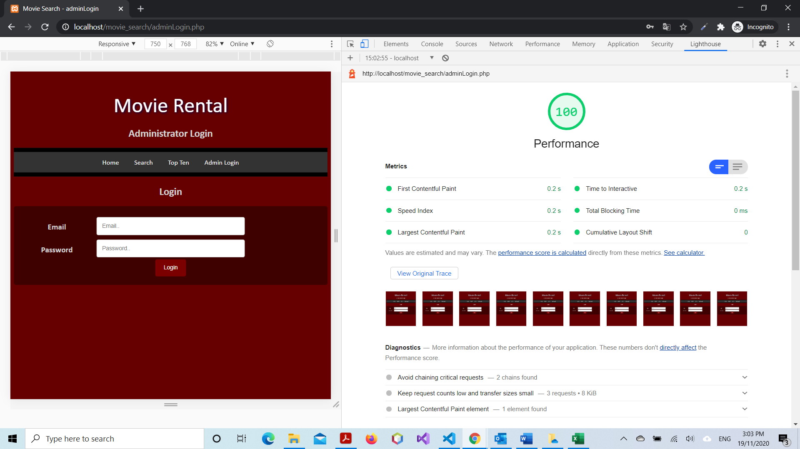

## Figure 5 - Unsubscribe Membership (unsubscribeMembership.php)

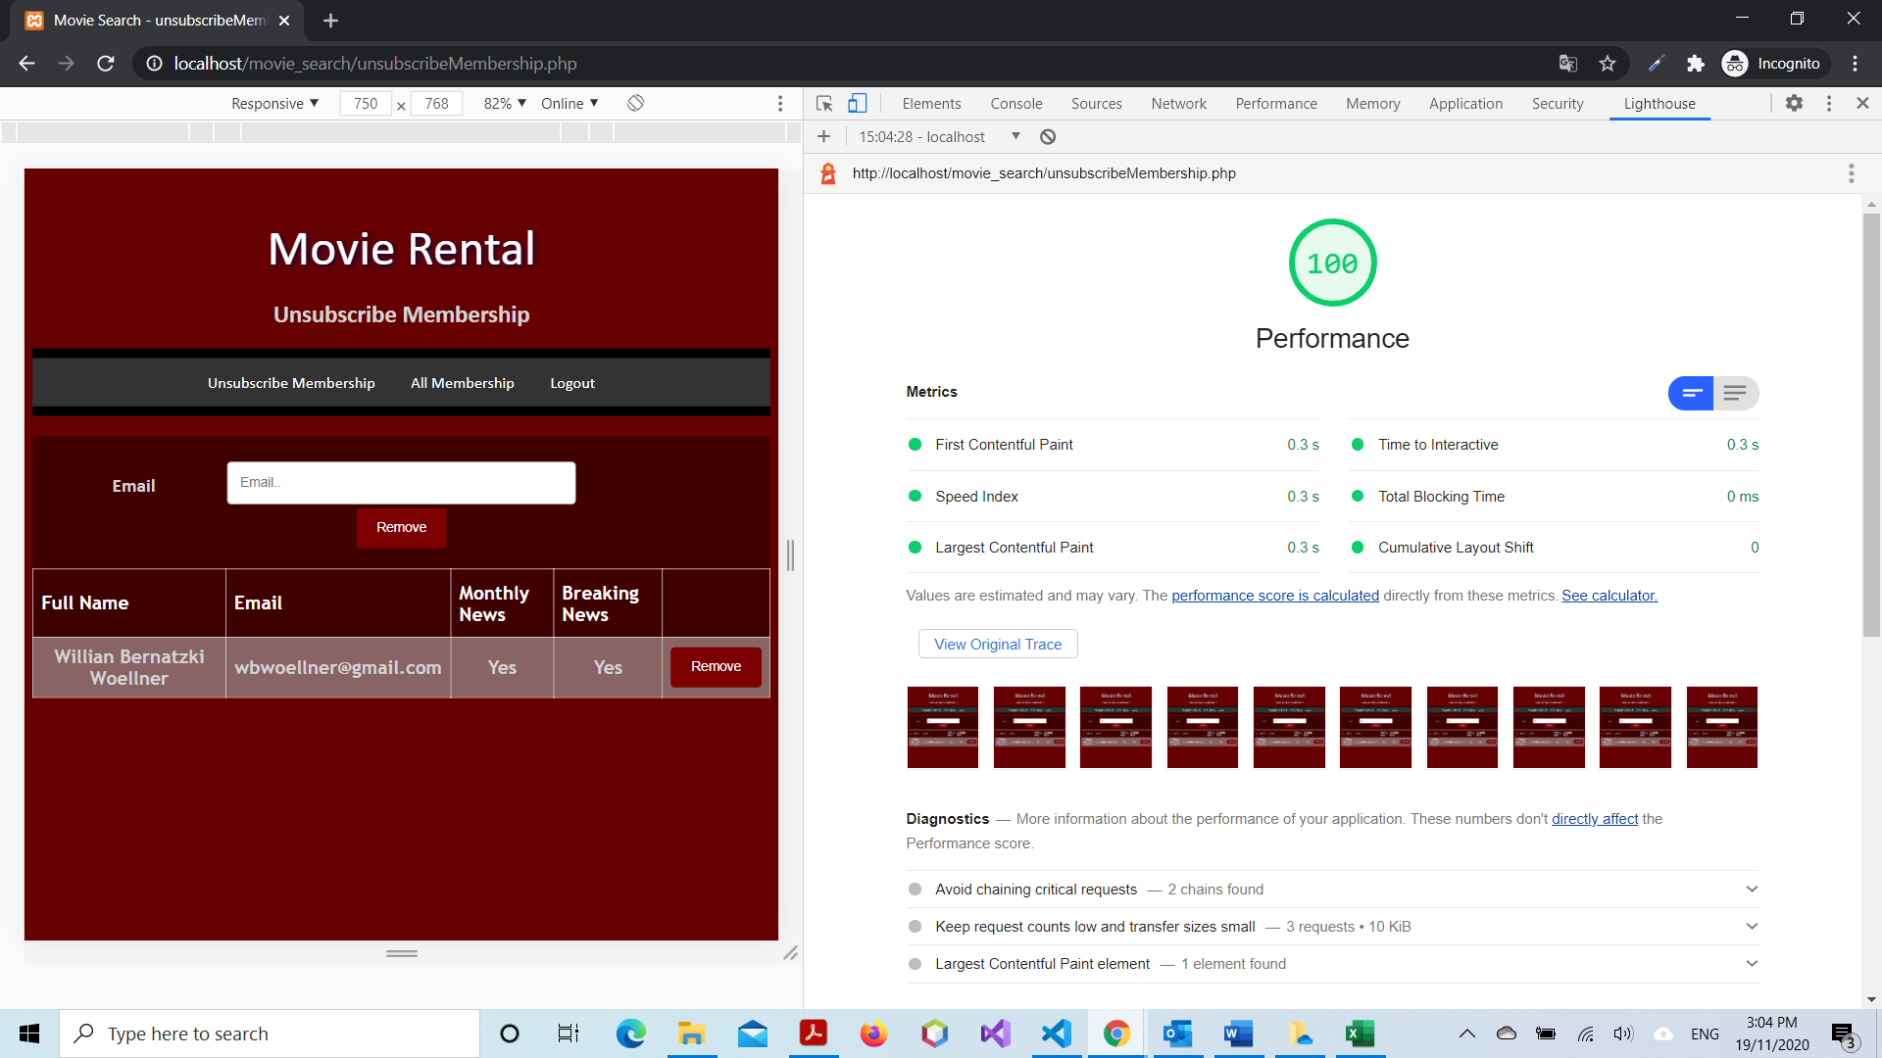

## Figure 6 - All Membership (allMembership.php)

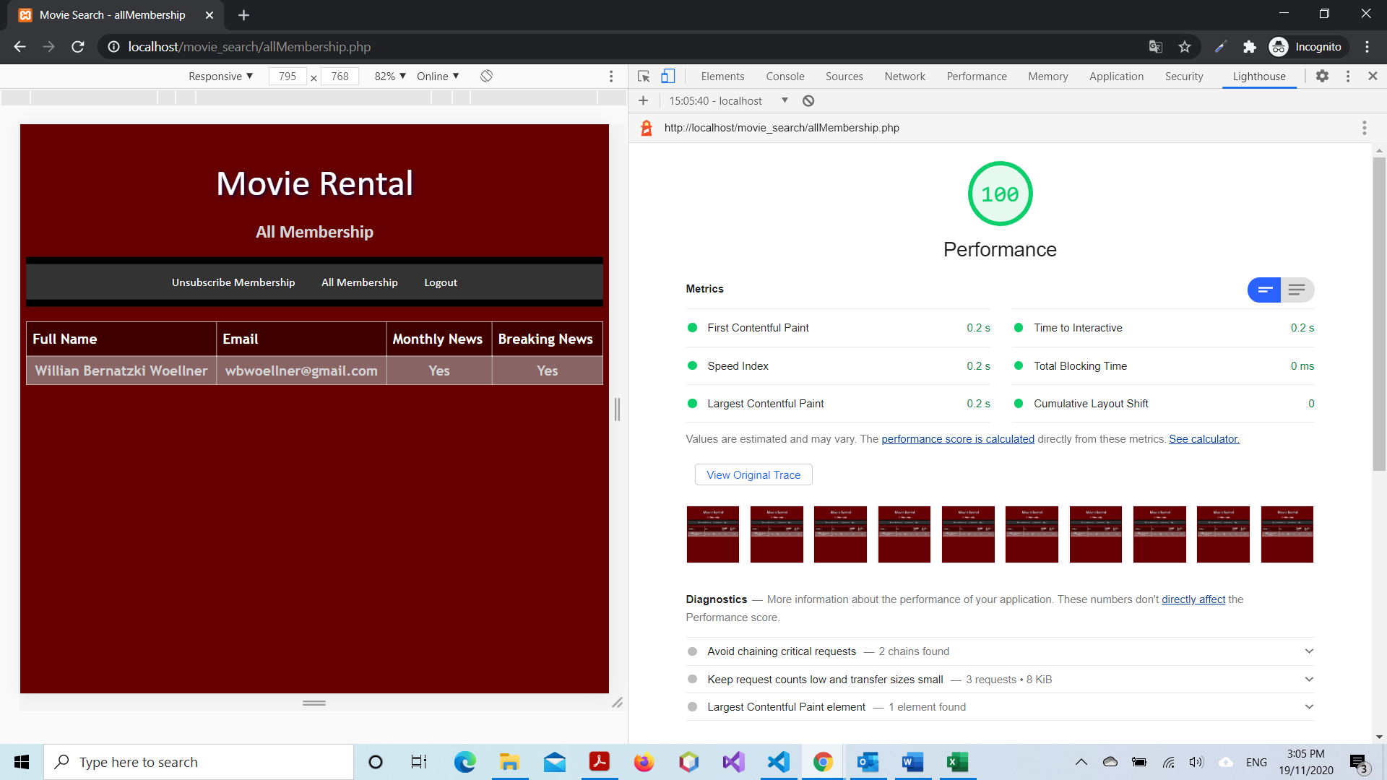

## Last Section - Result and Recommendation

|  |  |  |  |  |
| --- | --- | --- | --- | --- |
| **Page** | **File** | **Performance** | **Description result** | **Comment** |
| Top 10 | top_ten.php | 100% | No significant changes are necessary. | Ref. Figure 1 |

## Figure 1 – Top 10 (top_ten.php)

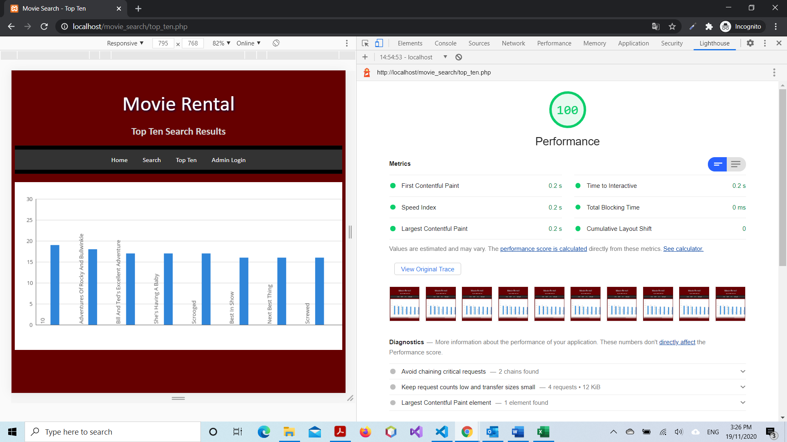

# References

*Lighthouse*. (2020, November 19). Retrieved from Developers Google: https://developers.google.com/web/tools/lighthouse